SEMESTER LONG INTERNSHIP PROGRAM (SLIP)REPORT

# ZS Associates

**Submitted By**

**Prajwal Chobitkar**

**B224144**

SCHOOL OF COMPUTER ENGINEERING

MIT ACADEMY OF ENGINEERING ALANDI (D), PUNE

*CERTIFICATE*

This is to certify that the “**Semester Long Internship Program (SLIP)” report** submitted by Prajwal Chobitkar (**PRN 0220200206)** is work done by him and is submitted during 2022-23 academic year.

# Faculty Mentor School - Internship Coordinator

Mr. Nilesh Navghare Mr. Krunal Pawar

# School Dean

Mrs. Rajeshwari M. Goudar

# INTERNSHIP BONAFIDE LETTER

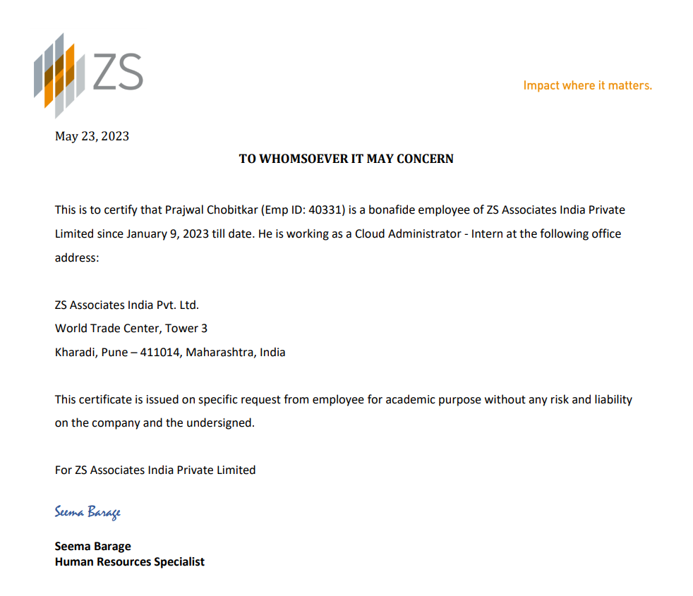

**ACKNOWLEDGEMENT**

I, Prajwal Chobitkar (0220200206) would like to convey my gratitude to the Management, Director, and Dean of MIT Academy of Engineering, Pune for emphasizing the 6 - months Semester Long Internship Program and giving me the platform to interact with industry professionals.

First, I would like to thank ZS Associates for giving me the opportunity to do an internship within the organization. I also would like all the people that worked along with me in ZS Associates with their patience and openness they created an enjoyable working environment.

I would like to thank my Head of the Department, Internship Coordinator, and Department of CSE for their support and advice to get and complete an internship in the above-said organization.

I am extremely grateful to my department staff members and friends who helped me in the successful completion of this internship.

# Prajwal Chobitkar

**Table of Contents**

|  |  |  |  |
| --- | --- | --- | --- |
| **Topic** | | | **Page No.** |
| 1. | **Introduction** | |  |
|  | 1.1 | Abstract | 6 |
|  | 1.2 | Introduction About ZS Associates | 6-7 |
|  | 1.3 | Introduction about CCoE | 8 |
|  | 1.4 | Introduction about Reporting Services Team | 9-12 |
| 2. | **Internship Discussion** | |  |
|  | 2.1 | Opportunity Description | 13 |
|  | 2.2 | Role description/statement | 13 |
|  | 2.3 | Scope | 13-14 |
|  | 2.4 | Implementation Details | 15-18 |
|  | 2.5 | Tools/Technologies used regularly | 19-23 |
|  | 2.6 | Most challenging tasks performed | 24 |
| 3. | **Conclusion** | | 25 |

# 1. INTRODUCTION

* 1. **Abstract of SLIP**

I am currently an intern at ZS Associates. The internship started on 9th January 2023 and will be completed on 31st June 2023. I was hired as a Cloud Application Administrator Intern in this organization.

# Description of ZS Associates

ZS Associates is a management consulting and professional services firm focusing on consulting, software, and technology, headquartered in Evanston, Illinois that provides services for clients in healthcare, private equity, and technology. The firm was founded in 1983 by two professors at Northwestern University who developed sales force alignment models using the world’s first personal-computer-aided territory mapping System.

ZS continues to offer sales force alignment service to this day, in addition to a range of professional services, many of which are supported by advanced analytics. In the endeavor to digitally transform businesses, organizations often need to grapple with delays and cost overruns which can diminish customer experience. Intelligent automation – backed by a scalable cloud-native solution that is equipped to discover, digitize, automate, and optimize processes across the entire enterprise – can help address this situation. Cloud-native architectures can drastically reduce cost as well as bring agility with on-demand expansion and auto-scaling to accommodate volume and capacity changes.

ZS, a global professional services firm, embarked on a journey to deliver true digital transformation to its clients and realized the importance of embracing a cloud-based,

automation-centric approach to achieve the desired result. The company believes in leveraging deep industry expertise, leading-edge technology, and an analytics-powered strategy to create solutions for customers that work in the real world.

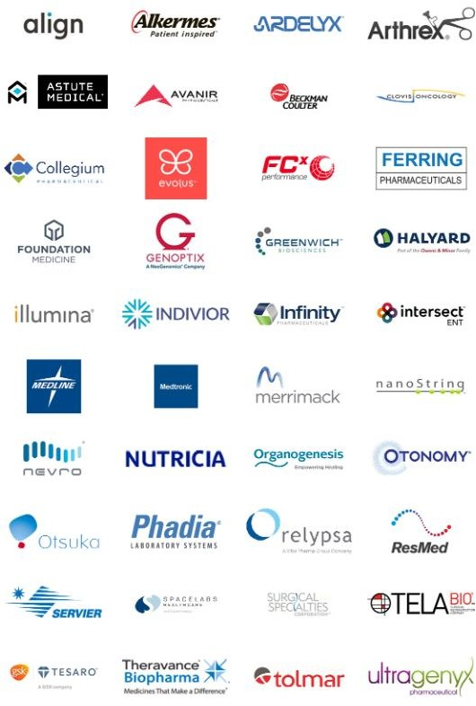

**Diag 1.2.a - Clients of ZS**

# CCoE (Cloud Center of Excellence) Team

Team builds, maintains, and helps architect the systems enabling ZS client-facing cloud software solutions. We define and implement best practices to ensure performant, resilient, and secure cloud solutions. The CCoE team at ZS is composed of analytical problem solvers coming from diverse backgrounds while sharing a passion for quality delivery — whether our customer is a client or another ZS employee.

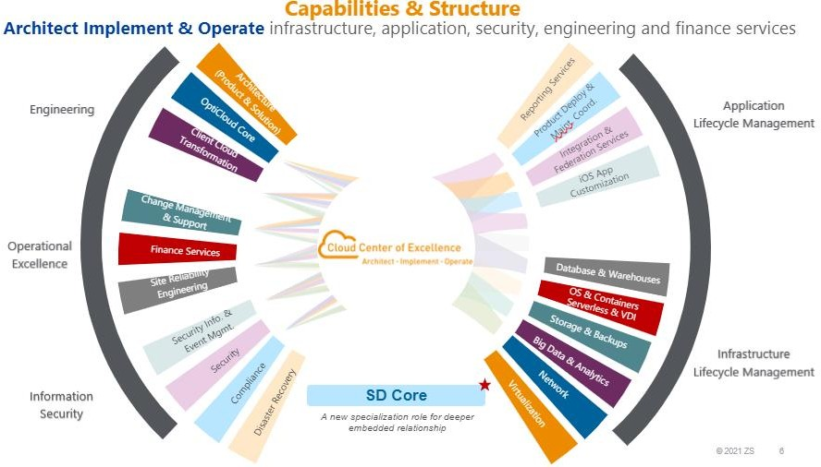

**Diag 1.3.a – Structure of CCoE**

# Reporting Services

Comprising of more than 25 members, Reporting Services’ duties revolve around the following points –

* + 1. Our team works on 6 different BI tools' administration:
       - **Microstrategy:** We handle the administration tasks for Microstrategy, which is a business intelligence and analytics platform. This includes managing user access, migrating the code, troubleshooting, installation and maintenance of environments and much more.
       - **Sisense:** We administer Sisense, a data analytics and visualization tool. Our responsibilities involve setting up data connections, maintaining the platform, user access, etc.
       - **Power BI:** Administration of Power BI involves tasks such as managing workspaces, configuring data gateways, and ensuring data security and access control.
       - **Tableau:** We handle the administration tasks for Tableau, a popular data visualization and reporting tool. This includes managing user access, configuring data sources, and monitoring server performance.
       - **Quicksight:** Quicksight administration involves tasks such as managing user permissions, configuring data sources for this Amazon Web Services (AWS) business intelligence tool, etc.
       - **RConnect:** RConnect is an R programming integration tool. We handle its administration, which includes managing R packages, configuring R environments, and ensuring smooth integration with other BI tools.

# Administration is concerned on both levels - Application and infrastructure:

* + - * **Application-level administration:** Thisinvolves managing user access, roles, and permissions within each BI tool. It also includes configuring data sources, scheduling data refreshes, troubleshooting, managing user access and maintainig

the overall functionality of the BI applications (apart from development).

* + - * **Infrastructure-level administration:** We are responsible for managing the underlying infrastructure on which the BI tools are hosted. This includes initiating setting up and maintaining AWS services like EC2 (Elastic Compute Cloud) for hosting servers, EFS (Elastic File System) for shared file storage, and other necessary components. We also develop and maintain scripts for automating various tasks.

# Different environments for different clients:

* + - * We work with multiple clients, and each client has their own set of environments for different stages of the software development lifecycle. These stages typically include development, stage, testing, and production environments. We ensure that the BI tools and their associated infrastructure are properly configured and maintained across these environments, ensuring consistency and data integrity.



**Diag 1.4.3 – different environments and code flow**

# Infrastructure hosted over AWS:

* + - * We leverage AWS services to host and manage the infrastructure for the BI tools. This includes utilizing services like EC2 for hosting servers that run the BI applications, EFS for shared file storage to store data and configuration files, and other AWS services as required. We also utilize scripts to automate tasks. 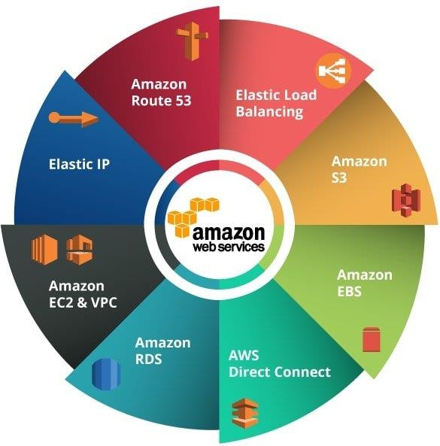

**Diag 1.4.4 – AWS Services**

# Compliance domain:

In addition to administering the BI tools and infrastructure, we also cover the compliance domain.

* + 1. **Application Development:** We have some team members specially dedicated to developing automations for various tasks like migrations, etc. They are also responsible for various application level tasks.

Overall, our team is responsible for administering multiple BI tools, managing both application- level and infrastructure-level tasks, working with different client environments, utilizing AWS services, developing automations, and ensuring compliance with relevant regulations.

# INTERNSHIP DISCUSSION

* 1. **Opportunity Description**

Currently, I have been appointed with administration of two BI tools –power bi And tableau. Tasks revolve around both aspects – application and infrastructure, hence the scope is also bigger. As per the role, we are required to tackle troubleshooting various issues on either levels, work arond with regular operations like migrations, user management, etc. as well perform installation and maintenance level tasks related to application level products. We also have to initiate and perform activities related to VAPTs(Vulnerability Assessment and Penetration testing), server upgrades, etc. We regularly have to communicate with various teams in and out of our organization for different activities. As infrastructure is hosted on AWS, we need to work with many of its services.

# Role description/statement

BI Tools’ (Tableau And Power Bi) administration – server and application level, maintaining infrastructure over AWS and continuously automating workflow.

# Scope

The domain of internship revolves around the administration of BI tools and applications. As administrators, we are required to possess expertise in these tools and their various aspects, including configuration, monitoring, and maintenance. This expertise allows us to effectively manage and optimize the performance of the BI applications.

Our role also extends to integrating and hosting these applications using various AWS technologies. This includes a comprehensive understanding of AWS services such as EC2 (Elastic Compute Cloud), EFS (Elastic File System), EKS (Elastic Kubernetes Service), and others that are relevant to the hosting and integration of the BI tools.

With regard to the BI tools, your expertise lies in their administration, which involves such as user management, role-based access control, configuration of security settings and much more. We are responsible for ensuring that the applications are properly configured and secured, allowing authorized users to access the necessary data and functionalities.

Configuration is a crucial aspect of role, as it involves setting up and managing data connections, managing data models, etc. within the BI tools. This requires a deep understanding of the data sources, integration methods, and visualization capabilities of the specific tools you are working with.

Monitoring is another important area of focus. As an administrator, we need to ensure the smooth operation of the BI applications by monitoring their performance, data refresh schedules, and system health. This includes identifying and addressing any issues or bottlenecks that may arise, ensuring that the applications consistently deliver accurate and up-to-date information.

# Implementation

As per the technology, following are the tasks that are currently ongoing or already completed by me till date –

# Regular tasks –

* + 1. **Migrations** Content migration in Tableau Server refers to the process of transferring dashboards, workbooks, data sources, and related content from one Tableau Server environment to another. It allows you to move Tableau content between different instances of Tableau Server or even across different environments such as from a development or staging environment to a production environment.

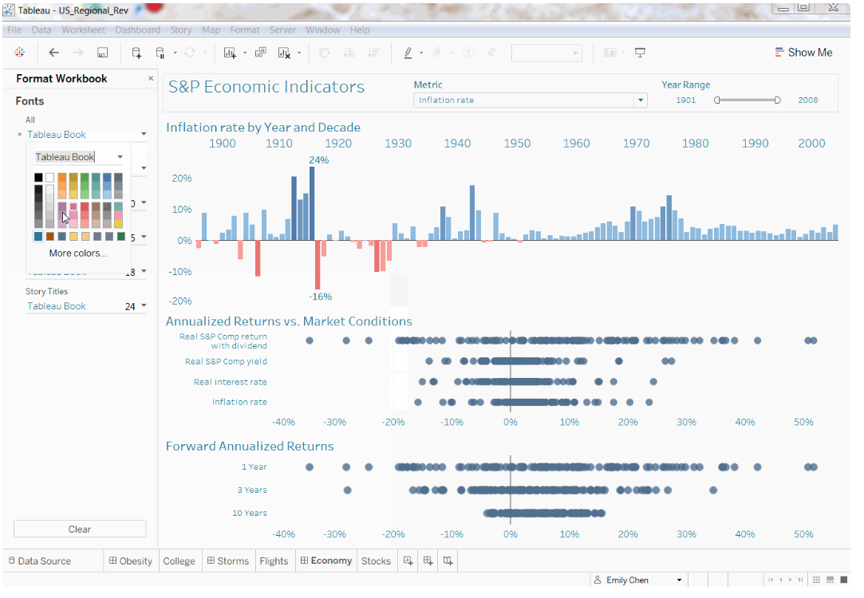

**Diag 2.4.1.a – Tableau Workbooks**

* + 1. **User management:** Created and managed users and groups within the tableau server platform. This includes tasks such as creating user accounts, assigning appropriate security filters and access control levels, configuring authentication methods, and updating access control lists (ACLs) and much more.

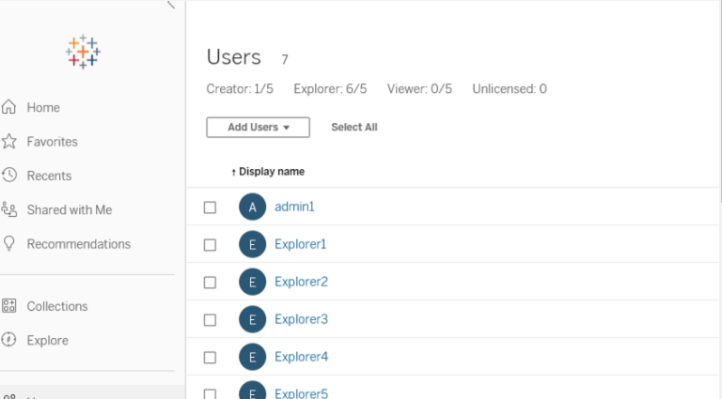

**Diag 2.4.1.b – User management in tableau server**

* + 1. **Creation of schedules and subscriptions:** Set up schedules to automate the execution of reports or data refreshes at specified intervals. Additionally, created subscriptions to deliver reports or dashboards to users via email or other distribution methods on a scheduled basis.

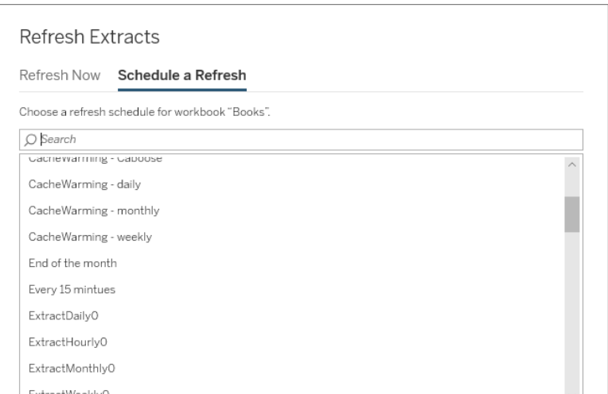

**Diag 2.4.1.c – Creating a refresh/subscription**

* + 1. **Monitoring server :**   
       Monitoring Tableau Server processes is crucial for ensuring the smooth operation and performance of your Tableau Server deployment. By monitoring the processes, you can identify potential issues, optimize resource usage, and troubleshoot any problems that may arise.

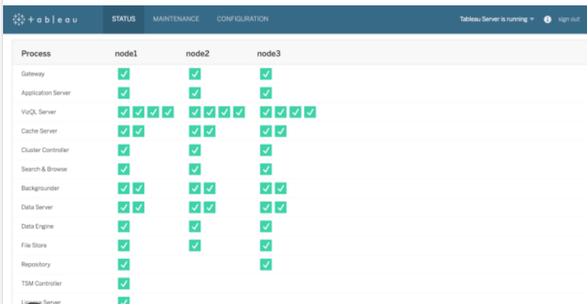 **Diag:2.4.1.d Server Processes**

1. **Content Publishing:**

Automate the process of publishing dashboards, workbooks, and data sources to Tableau Server. You can use Tableau Server's REST API or command-line tools like "tabcmd" to script the publishing process. This enables you to schedule content updates or automatically publish new content from external sources.

1. **Changing configurations for project or server level:**

Made configuration changes at both the project and server levels in tableau These changes could include adjusting settings, parameters, or preferences to optimize performance, security, or functionality.

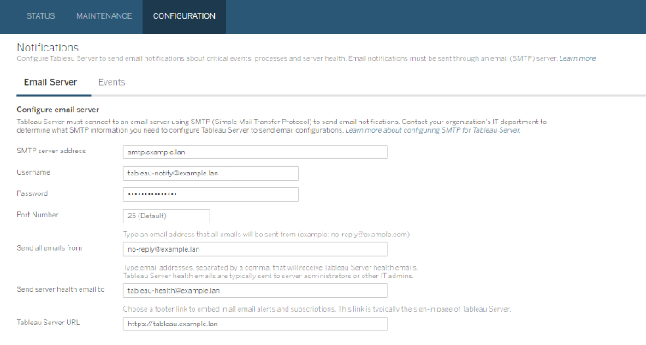

**Diag 2.4.1.e – Project configuration through server**

1. **Troubleshooting basic issues:** Dealt with basic troubleshooting tasks, resolving issues that arise within the application. This could involve investigating and resolving errors, resolving connectivity issues, or addressing performance-related concerns.
2. **Monitoring:** monitored utilization of resources, status, etc. in an environment (infrastructure) over tools like cloudwatch, uptrends, etc.

# 2.5 Tools/Technologies used regularly

1. **ServiceNow:** required for managing operations (changes like access, migrations, activities or upgrades, etc.)
2. **Teamcity:** TeamCity is a popular continuous integration and continuous delivery (CI/CD) server developed by JetBrains. It is a powerful tool for automating build, test, and deployment processes in software development projects. TeamCity provides a range of features that help teams streamline their development workflows and ensure the consistent delivery of high-quality software.
   * Build Automation: TeamCity supports various build systems and build runners, allowing you to automate the build process for your applications. It integrates with popular build tools such as Maven, Gradle, MSBuild, and more. TeamCity can trigger builds automatically based on events like code commits, schedule builds at specific times, or manually initiate builds
   * Test Automation: TeamCity enables you to automate testing processes and run tests as part of your CI pipeline. It provides support for different testing frameworks and can execute unit tests, integration tests, and other types of tests. TeamCity can collect and present test results, generate reports, and send notifications about test failures.
   * Continuous Integration: With TeamCity, you can establish a continuous integration workflow, where code changes are frequently integrated and built. TeamCity can monitor your version control system (such as Git, Subversion, or Mercurial), detect changes, and trigger builds automatically. It helps ensure that new code is quickly validated and integrated with the existing codebase.
   * Integration with Version Control: TeamCity has tight integration with version control systems, providing features like source code checkout, change detection, and branch management. It supports popular version control systems like Git, Mercurial, Subversion, and Perforce. TeamCity can detect changes in your repository, trigger builds, and provide detailed information about the changes in the build history.
   * Extensibility and Integrations: TeamCity offers a plugin-based architecture that allows you to extend its functionality or integrate with other tools. It has a wide range of plugins available for popular tools and technologies. Additionally, TeamCity provides APIs that enable you to create custom integrations or build additional features tailored to your specific needs.
3. **Shell Scripting:** required for bash script automations and regular tasks concerned with application operations.

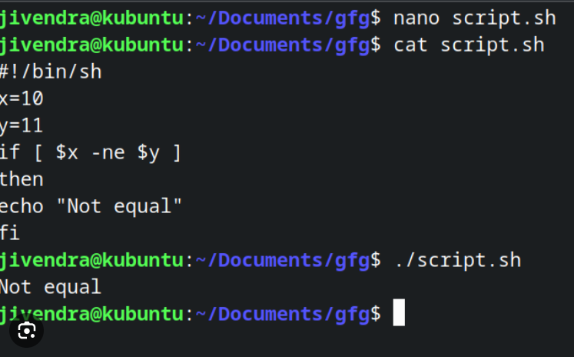

**Diag 2.5.3.1 – Bash Script**

# Tableau tools:

* + **Server:** Used intensively to perform administrative tasks like =

1. **User and Security Management:** allows you to manage user access and security settings within the context of the projects you are working on. You can define user roles, assign privileges, and control access to data and functionality.
2. **Project Configuration:** you can configure project-specific settings, such as database connections, data source credentials, project-level caching, and other project- related parameters. These configurations help tailor the project to specific requirements and optimize its performance.

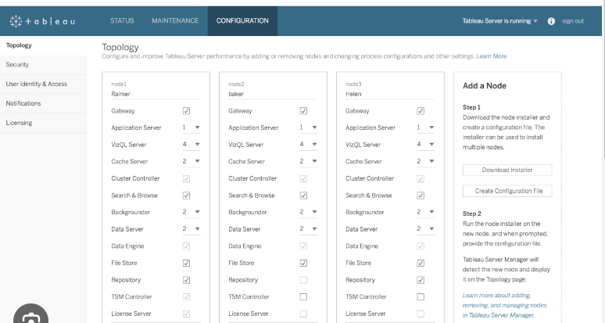

**Diag 2.5.4.1 – Server Configuration**

# Monitoring tools:

* + **Cloudwatch:**

AWS CloudWatch is a powerful monitoring and observability service provided by Amazon Web Services. It offers a range of features to help you monitor, analyze, and react to changes in your AWS resources and applications.

With CloudWatch, we can collect and track metrics from various AWS services and resources, providing insights into their performance and utilization. we can create custom dashboards to visualize these metrics and gain a consolidated view of your system's health.

CloudWatch allows you to set alarms based on metric thresholds, enabling us to receive notifications or trigger automated actions when certain conditions are met. This proactive approach helps you respond quickly to any issues or anomalies in your environment.

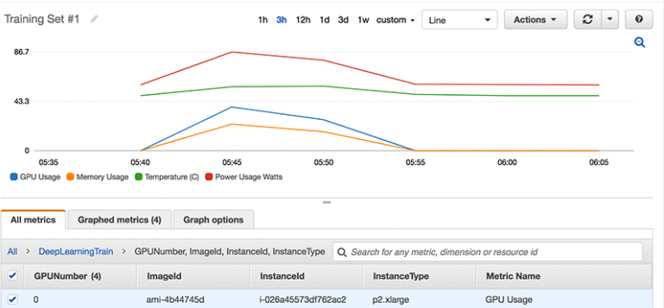

**Diag 2.5.5.1 – Cloudwatch**

* + **Uptrends:** Uptrends is a website and server monitoring tool that helps ensure the availability and performance of web applications and infrastructure. It performs regular checks on websites, APIs, servers, and network resources to detect issues such as downtime, slow response times, or errors. Uptrends provides real-time alerts, performance reports, and uptime statistics, enabling organizations to proactively identify and resolve performance issues.
  + **Splunk:** Splunk is a leading data analytics and log management platform used for collecting, analyzing, and visualizing machine-generated data. It allows organizations to index and search through large volumes of data from various sources, including logs, events, and metrics. Splunk provides powerful search capabilities, machine learning-driven insights, and visualization options to gain operational intelligence and troubleshoot issues effectively.

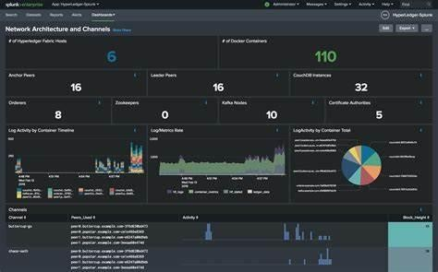

**Diag 2.5.5.2 – Splunk**

1. **AWS Services like EC2, ALB, etc. :** Amazon Web Services (AWS) offers a comprehensive suite of cloud computing services that provide on-demand computing power, storage, and other resources. As our infrastructures are hosting on AWS cloud itself, we have to work with various services regularly.

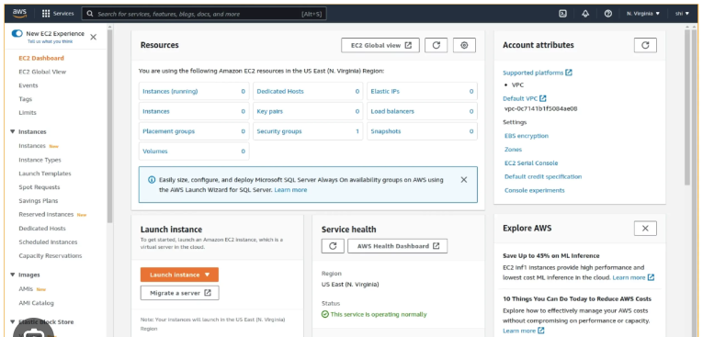

**Diag 2.5.6.1 – Splunk**

# Most challenging tasks performed

1. **Deployment Over Teamcity :**

TeamCity is a powerful and user-friendly continuous integration and delivery (CI/CD) server that automates build, test, and deployment processes, ensuring efficient software development workflows.

As a fresher i was unaware of teamcity I had not deployed any solution anywhere in the past as this was the production deployment it was very necessary to deploy it over a reliable system in concern with security as the password to server was injected in the script itself.

1. **Tableau online POC:**

Tableau Online is a cloud-based version of the Tableau platform offered by Tableau Software. It allows users to publish, share, and collaborate on Tableau dashboards, reports, and visualizations over the internet.

As this was my first project I often struggled with adhering to timelines and consistently meeting deadlines. As we have to report findings to the business teams and the concept was also overall new to me so I frequently encountered numerous inquiries regarding functionality, service, security, and costing, necessitating multiple case submissions to the product team for clarifications and further understanding.

1. **Evaluation of new server version:**

We evaluated the new version of Tableau Server to assess its features, enhancements, and overall compatibility with our organization's requirements. This evaluation process involves thoroughly examining the new version's functionality, performance, security, and any other relevant aspects to determine its potential value and benefits for our organization.

# 3. CONCLUSION

During your internship tenure, I had the opportunity to enhance my skills and develop both technically and behaviorally. In terms of technical growth, I learned and performed administrative tasks for two popular BI tools, Power Bi and Tableau. This hands-on experience equipped me with practical knowledge and expertise in managing these tools effectively.

In addition to BI tools, I also gained valuable practical knowledge in working with AWS and its various services. This exposure to AWS technologies, such as EC2, EFS, and others, provided me with a solid foundation in cloud infrastructure and integration, which is highly relevant and sought after in the industry.

Beyond the technical aspects, my internship experience had a significant impact on your personal and professional development.

Overall, this internship opportunity provided me with practical and challenging experiences that fostered continuous learning and personal growth. The technical skills I acquired, combined with the understanding of team dynamics, organizational culture, and time management, will positively impact both my professional career and personal development. The knowledge and experiences gained during this internship will serve as a solid foundation for my future endeavors and contribute to my overall success.